Installing SQL Server 2014 Developer (64 bit on Windows Server)
- Go to installs directory
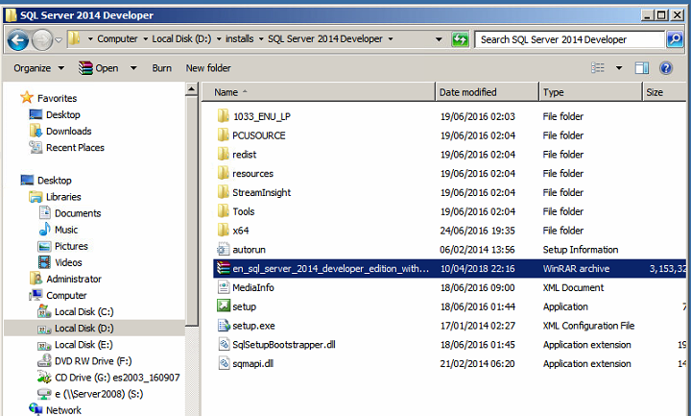
- Double Click on Setup

- Click on Tools in the left menu. Then click on “System Configuration Checker”
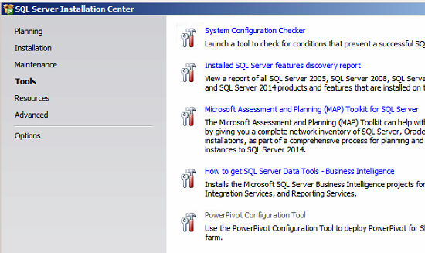
- Make sure everything is ok up to this point as far as system configuration is concerned
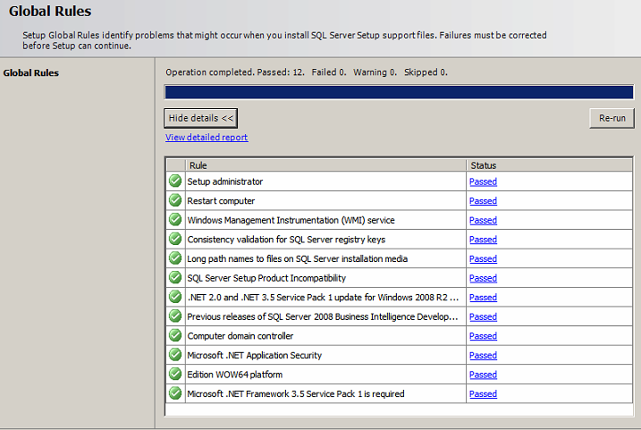
- Click on Installation in the left menu. Click on “New SQL Server standalone installation”
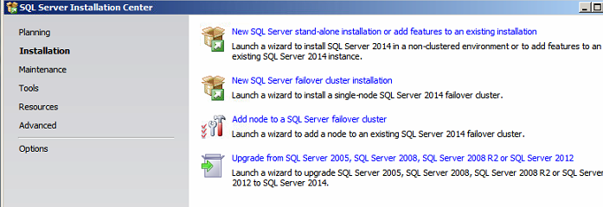
- Select ‘SQL Server Feature Installation’
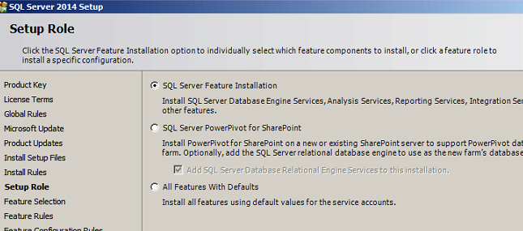
- Feature Selection – Select All – Install in C:\ (on the server) (Untick some shown)
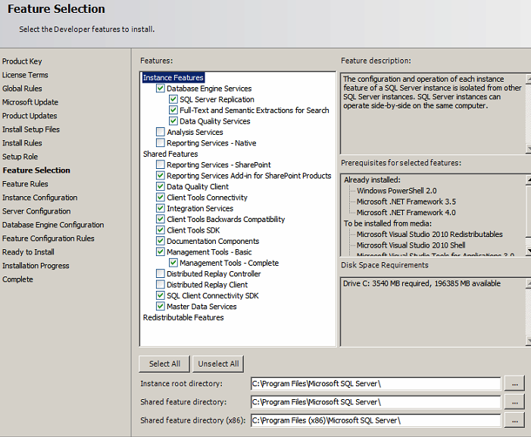
- Instance Configuration : SQL_SERVER_2014
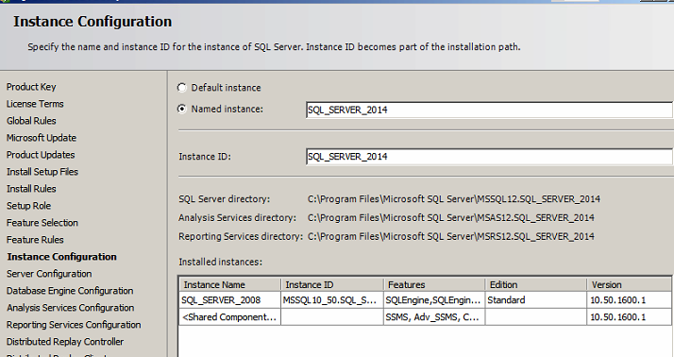
- Server Configuration
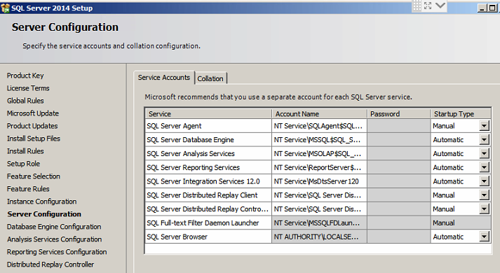
- Database Engine Configuration
  - Server Configuration
    - Pwd – sa123@pwd
    - Click on ‘add current user’
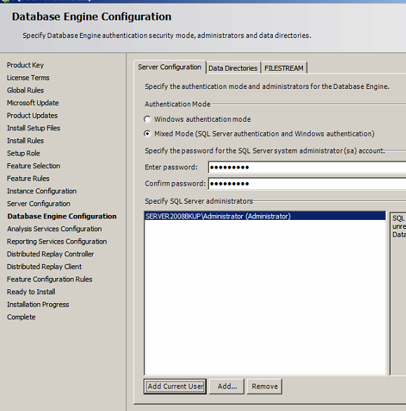
  - Data Directories
    - Specify default data directories and backup directory
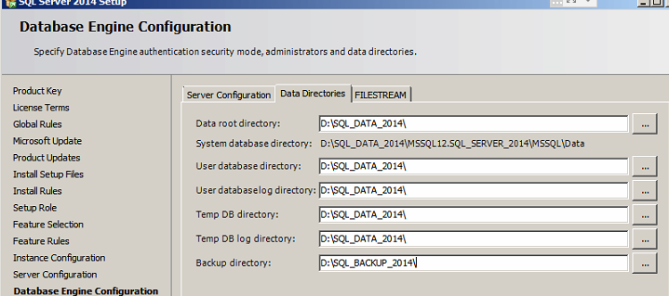
- Ready to Install
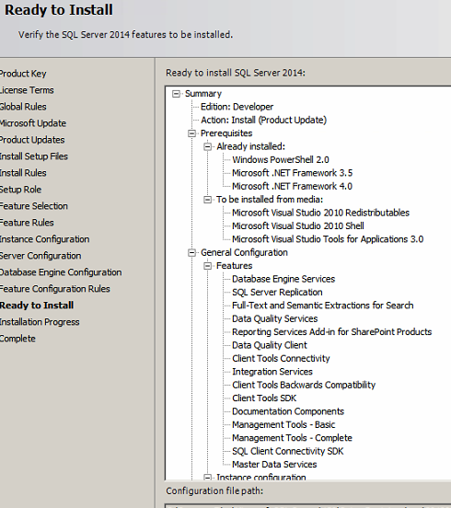
- Now the installation should be complete

Open SQL Management Studio for SQL Server 2014
- Open Management Studio 2014
  - Login: sa
  - Pwd: sa123@pwd
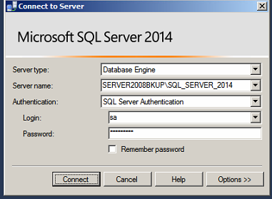
- Right Click on Databases -> New Database
  - It should get created in the SQL_DATA_2014 folder
- *** Sometimes the backup and restore from the Management Studio Interface does not work
- You may have to backup this database manually like ‘BACKUP DATABASE Jadoo_2006.bak TO DISK='D:\SQL_BACKUP_2014\Jadoo_2006.bak'’
- And then restore the same like ‘RESTORE DATABASE Jadoo_2006
FROM DISK = ‘D:\SQL_BACKUP_2014\Jadoo_2006.bak’ WITH REPLACE’
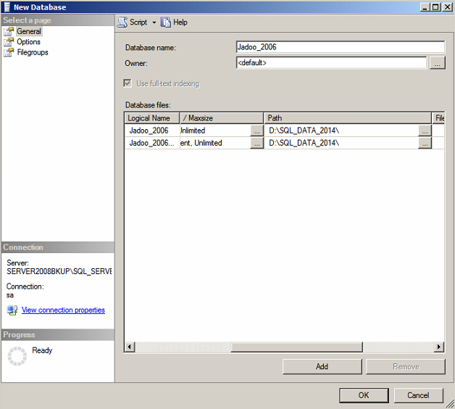
- Right click on the database Jadoo_2006 and click on Backup (dummy backup)
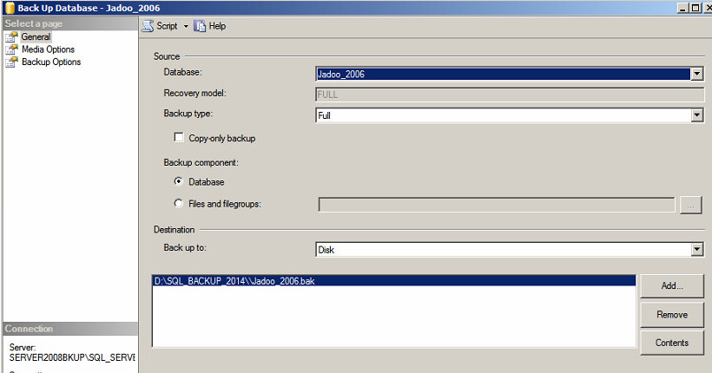
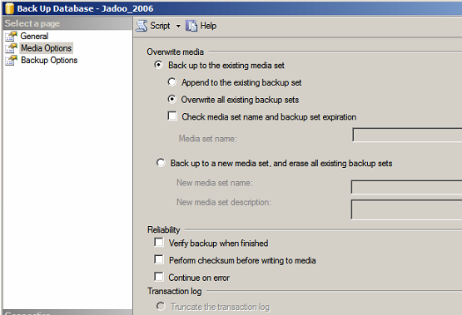
- Now restore the same dummy database. (This is done since SQL Serve sometimes gives some error message regarding backups)
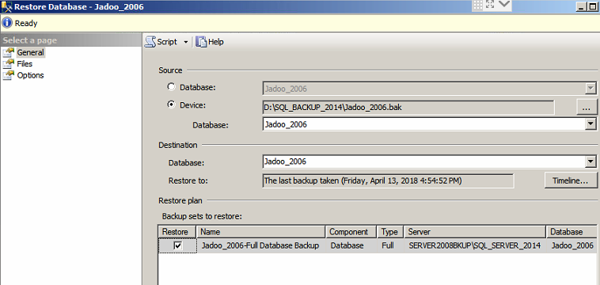
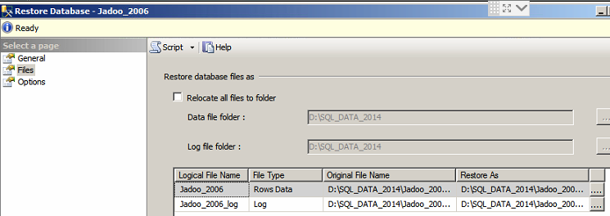
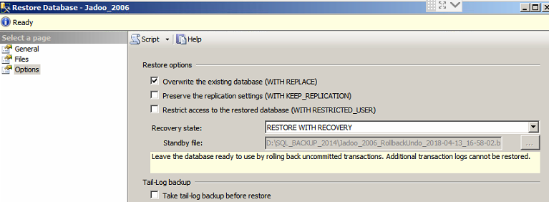
- Now copy the actual Jadoo_2006.bak into the SQL_BACKUP_2014 folder and restore it from there.
- Delete the Jadoo_2006.bak from the SQL_BACKUP_2014 folder and backup Jadoo_2006.bak into this folder. It sometimes does not allow an overwrite from 64 to 32 bit baks.

- The application then works from the server. But from the network it may still give a problem. To overcome that

  - Check firewall settings in Windows
  - Turn on TCP/IP from Configuration Manager
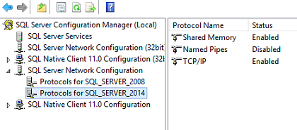
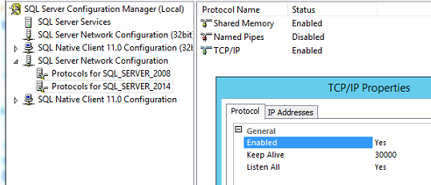
- On Windows Command Prompt
  - Ipconfig
  - IPv4 Address 192.168.1.10
- Open Management Studio
  - Right click on SQL Server -> Properties -> Security
  - Enable SQL Server & Windows Authentication Mode
  - Connections -> Allow Remote Connections
  - Restart SQL Server
- Open Configuration Manager
  - SQL Server Network Configuration
    - Protocols for SQL Server
    - In Right Pane, ensure that TCP/IP is enabled
  - Right click on TCP/IP
    - Click on the ‘IP Addresses’
    - Go to the bottom -> IP All
      - TCP Port 1433
      - TCP Dynamic Ports – blank out
  - On the left Pane -> SQL server Services
    - SQL Server -> Right Click -> Restart
